**AIR CRASH SITE TRACKING USING PSO**

**PROBLEM STATEMENT:**

Whenever there is a plane crash in the ocean it is necessary to reach the crash site for a rescue mission quickly. Any delay in reaching the crash site may result in loss of lives, loss of wreckage deep into the sea & loss of black box which is very important to be found out for investigation of the air crash.

___________________________________________________________________________

**PROPOSED SOLUTION:**

This problem can be solved by using **particle swarm optimization.**

The coordinates (x, y) of the air crash site will be shared among all the boats for a rescue mission.

The boats(particles) will basically use the knowledge of other particles to change their position and reach the destination quickly.

Algorithm:

1. Each boat will be assigned an initial location & velocity.
2. Fitness value of each boat will be maintained in a list. This fitness function is nothing but the calculation of Euclidean distance from the particles current position and the destination coordinates.
3. Personal best & Personal best location of each boat is the corresponding fitness value and the current location.

**LOOP UNTIL t < 100 & err >ERR_TOLERANCE**

1. Update Personal best
   1. If fitness value is less than personal best

update the personal best of that swarm with the fitness value.

update the personal best location with current location of boat

1. Update Global best
   1. Get the index of the minimum value from the fitness value list
   2. Get the value from the fitness value list using that index
   3. If the value is less than global best
      1. Update the global best with that value
      2. Update global location with the location of the best swarm in fitness list

**LOOP FOR EACH SWARM (BOAT)**

1. Update Velocity of boat

newVel[i] = (w * p.getVelocity().getPos()[0]) +

(r1 * C1) *

(pBLoc.get(i).getLoc()[0] - p.getLocation().getLoc()[0]) +

(r2 * C2) * (gBLoc.getLoc()[0] - p.getLocation().getLoc()[0]);

newVel[i] = (w * p.getVelocity().getPos()[1]) +

(r1 * C1) *

(pBLoc.get(i).getLoc()[1] - p.getLocation().getLoc()[1]) +

(r2 * C2) * (gBLoc.getLoc()[1] - p.getLocation().getLoc()[1]);

1. Update Location of boat

newLoc[0] = p.getLocation().getLoc()[0] + newVel[0];

newLoc[1] = p.getLocation().getLoc()[1] + newVel[1];

1. err = *evaluate*(gBLoc);

minimizing the functions means it's getting closer to 0

1. Display global best location x & y coordinates
2. Display fitness value of Global best location
3. Update the fitness list

**LOOP FOR EACH SWARM (BOAT) ENDS**

**LOOP UNTIL t < 100 & err >ERR_TOLERANCE**

DISPLAY THE GLOBAL BEST LOCATION x & y coordinates which is nothing but the coordinates where the solution is found.

___________________________________________________________________________

**SCREENSHOT OF OUTPUT:**

Destination of air crash site is given as (3,2.5)

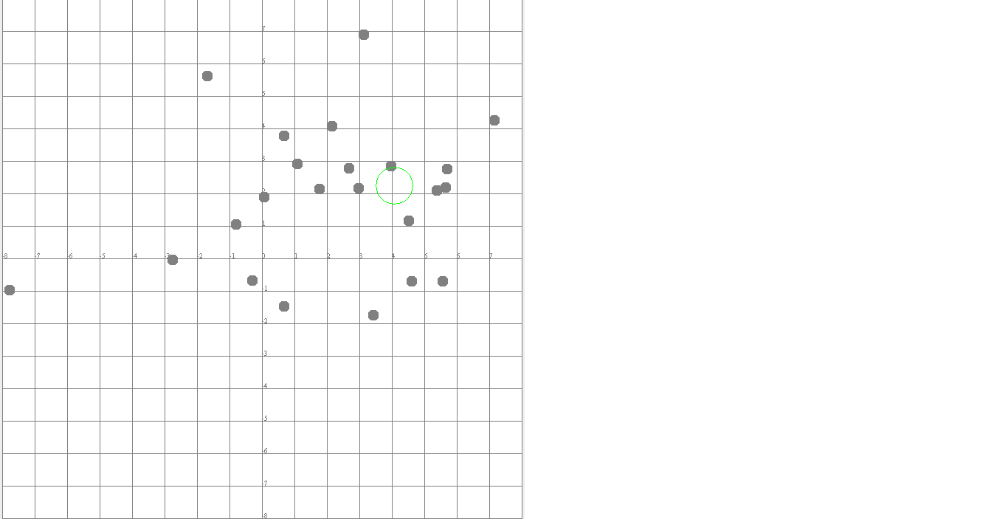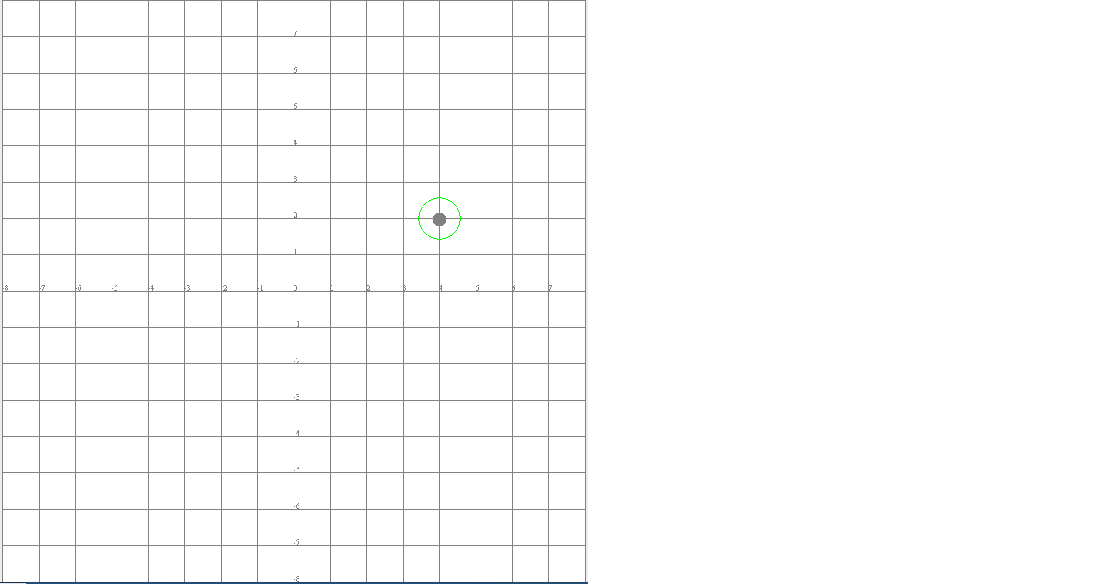

**___________________________________________________________________________**

**USE CASE:**

1. **This algorithm is used for tracking of air crash site in ocean**
2. **This can also be used for finding black box which is very important component for investigation of air crash**
3. **It can also be used for finding plan crash site in dense forest where rescue operation can be performed by people.**

**REPORT OF OUTPUT:**

GLOBAL BEST LOCATION FOR ITERATION 0:

BOAT X COORDINATE: 1.224397711499119

BOAT Y COORDINATE: 2.330779780773584

Value: 0.793847839653696

_______________________________________________

GLOBAL BEST LOCATION FOR ITERATION 1:

BOAT X COORDINATE: 1.8511567849238095

BOAT Y COORDINATE: 2.61425981345899

Value: 0.18764223310838182

_______________________________________________

GLOBAL BEST LOCATION FOR ITERATION 2:

BOAT X COORDINATE: 1.8511567849238095

BOAT Y COORDINATE: 2.61425981345899

Value: 0.18764223310838182

_______________________________________________

GLOBAL BEST LOCATION FOR ITERATION 3:

BOAT X COORDINATE: 1.8511567849238095

BOAT Y COORDINATE: 2.61425981345899

Value: 0.18764223310838182

_______________________________________________

GLOBAL BEST LOCATION FOR ITERATION 4:

BOAT X COORDINATE: 1.8511567849238095

BOAT Y COORDINATE: 2.61425981345899

Value: 0.18764223310838182

_______________________________________________

GLOBAL BEST LOCATION FOR ITERATION 5:

BOAT X COORDINATE: 1.8511567849238095

BOAT Y COORDINATE: 2.61425981345899

Value: 0.18764223310838182

_______________________________________________

GLOBAL BEST LOCATION FOR ITERATION 6:

BOAT X COORDINATE: 1.8511567849238095

BOAT Y COORDINATE: 2.61425981345899

Value: 0.18764223310838182

_______________________________________________

GLOBAL BEST LOCATION FOR ITERATION 7:

BOAT X COORDINATE: 1.8466719868525532

BOAT Y COORDINATE: 2.608112639429068

Value: 0.18761082703315213

_______________________________________________

GLOBAL BEST LOCATION FOR ITERATION 8:

BOAT X COORDINATE: 1.8466719868525532

BOAT Y COORDINATE: 2.608112639429068

Value: 0.18761082703315213

_______________________________________________

GLOBAL BEST LOCATION FOR ITERATION 9:

BOAT X COORDINATE: 1.8466719868525532

BOAT Y COORDINATE: 2.608112639429068

Value: 0.18761082703315213

_______________________________________________

GLOBAL BEST LOCATION FOR ITERATION 10:

BOAT X COORDINATE: 1.8466719868525532

BOAT Y COORDINATE: 2.608112639429068

Value: 0.18761082703315213

_______________________________________________

GLOBAL BEST LOCATION FOR ITERATION 11:

BOAT X COORDINATE: 2.0489191997108156

BOAT Y COORDINATE: 2.412853780979782

Value: 0.09993773856690219

_______________________________________________

GLOBAL BEST LOCATION FOR ITERATION 12:

BOAT X COORDINATE: 2.0489191997108156

BOAT Y COORDINATE: 2.412853780979782

Value: 0.09993773856690219

_______________________________________________

GLOBAL BEST LOCATION FOR ITERATION 13:

BOAT X COORDINATE: 2.0489191997108156

BOAT Y COORDINATE: 2.412853780979782

Value: 0.09993773856690219

_______________________________________________

GLOBAL BEST LOCATION FOR ITERATION 14:

BOAT X COORDINATE: 2.0199839652026723

BOAT Y COORDINATE: 2.4063048415484425

Value: 0.09580261782688448

_______________________________________________

GLOBAL BEST LOCATION FOR ITERATION 15:

BOAT X COORDINATE: 2.0533928341844865

BOAT Y COORDINATE: 2.5130672896718336

Value: 0.05496861651542339

_______________________________________________

GLOBAL BEST LOCATION FOR ITERATION 16:

BOAT X COORDINATE: 2.0399688279372756

BOAT Y COORDINATE: 2.488695500886886

Value: 0.041536717574670465

_______________________________________________

GLOBAL BEST LOCATION FOR ITERATION 17:

BOAT X COORDINATE: 2.0260385988089578

BOAT Y COORDINATE: 2.4813285616490615

Value: 0.032041086717318985

_______________________________________________

GLOBAL BEST LOCATION FOR ITERATION 18:

BOAT X COORDINATE: 1.992344213817728

BOAT Y COORDINATE: 2.4769443558646476

Value: 0.024293492720575953

_______________________________________________

GLOBAL BEST LOCATION FOR ITERATION 19:

BOAT X COORDINATE: 1.992344213817728

BOAT Y COORDINATE: 2.4769443558646476

Value: 0.024293492720575953

_______________________________________________

GLOBAL BEST LOCATION FOR ITERATION 20:

BOAT X COORDINATE: 1.992344213817728

BOAT Y COORDINATE: 2.4769443558646476

Value: 0.024293492720575953

_______________________________________________

GLOBAL BEST LOCATION FOR ITERATION 21:

BOAT X COORDINATE: 1.992344213817728

BOAT Y COORDINATE: 2.4769443558646476

Value: 0.024293492720575953

_______________________________________________

GLOBAL BEST LOCATION FOR ITERATION 22:

BOAT X COORDINATE: 1.992344213817728

BOAT Y COORDINATE: 2.4769443558646476

Value: 0.024293492720575953

_______________________________________________

GLOBAL BEST LOCATION FOR ITERATION 23:

BOAT X COORDINATE: 1.992344213817728

BOAT Y COORDINATE: 2.4769443558646476

Value: 0.024293492720575953

_______________________________________________

GLOBAL BEST LOCATION FOR ITERATION 24:

BOAT X COORDINATE: 1.992344213817728

BOAT Y COORDINATE: 2.4769443558646476

Value: 0.024293492720575953

_______________________________________________

GLOBAL BEST LOCATION FOR ITERATION 25:

BOAT X COORDINATE: 1.992344213817728

BOAT Y COORDINATE: 2.4769443558646476

Value: 0.024293492720575953

_______________________________________________

GLOBAL BEST LOCATION FOR ITERATION 26:

BOAT X COORDINATE: 1.992344213817728

BOAT Y COORDINATE: 2.4769443558646476

Value: 0.024293492720575953

_______________________________________________

GLOBAL BEST LOCATION FOR ITERATION 27:

BOAT X COORDINATE: 1.992344213817728

BOAT Y COORDINATE: 2.4769443558646476

Value: 0.024293492720575953

_______________________________________________

GLOBAL BEST LOCATION FOR ITERATION 28:

BOAT X COORDINATE: 2.002155696391184

BOAT Y COORDINATE: 2.478373906222089

Value: 0.02173326848456003

_______________________________________________

GLOBAL BEST LOCATION FOR ITERATION 29:

BOAT X COORDINATE: 2.002155696391184

BOAT Y COORDINATE: 2.478373906222089

Value: 0.02173326848456003

_______________________________________________

GLOBAL BEST LOCATION FOR ITERATION 30:

BOAT X COORDINATE: 1.9958797008471034

BOAT Y COORDINATE: 2.5213362164754813

Value: 0.02173041643866867

_______________________________________________

GLOBAL BEST LOCATION FOR ITERATION 31:

BOAT X COORDINATE: 1.9958797008471034

BOAT Y COORDINATE: 2.5213362164754813

Value: 0.02173041643866867

_______________________________________________

GLOBAL BEST LOCATION FOR ITERATION 32:

BOAT X COORDINATE: 1.9958797008471034

BOAT Y COORDINATE: 2.5213362164754813

Value: 0.02173041643866867

_______________________________________________

GLOBAL BEST LOCATION FOR ITERATION 33:

BOAT X COORDINATE: 1.9821009287660287

BOAT Y COORDINATE: 2.4999422365225055

Value: 0.01789916444022207

_______________________________________________

GLOBAL BEST LOCATION FOR ITERATION 34:

BOAT X COORDINATE: 1.994587196995356

BOAT Y COORDINATE: 2.507226075786405

Value: 0.009028544048624396

_______________________________________________

GLOBAL BEST LOCATION FOR ITERATION 35:

BOAT X COORDINATE: 1.994587196995356

BOAT Y COORDINATE: 2.507226075786405

Value: 0.009028544048624396

_______________________________________________

GLOBAL BEST LOCATION FOR ITERATION 36:

BOAT X COORDINATE: 1.994587196995356

BOAT Y COORDINATE: 2.507226075786405

Value: 0.009028544048624396

_______________________________________________

GLOBAL BEST LOCATION FOR ITERATION 37:

BOAT X COORDINATE: 2.00301349974982

BOAT Y COORDINATE: 2.506776145454046

Value: 0.0074160183357751585

_______________________________________________

GLOBAL BEST LOCATION FOR ITERATION 38:

BOAT X COORDINATE: 2.0017788062916666

BOAT Y COORDINATE: 2.50529674285691

Value: 0.005587453509023735

_______________________________________________

GLOBAL BEST LOCATION FOR ITERATION 39:

BOAT X COORDINATE: 2.000396118987939

BOAT Y COORDINATE: 2.5003153262049422

Value: 5.063011634679591E-4

_______________________________________________

GLOBAL BEST LOCATION FOR ITERATION 40:

BOAT X COORDINATE: 2.000396118987939

BOAT Y COORDINATE: 2.5003153262049422

Value: 5.063011634679591E-4

_______________________________________________

GLOBAL BEST LOCATION FOR ITERATION 41:

BOAT X COORDINATE: 2.000396118987939

BOAT Y COORDINATE: 2.5003153262049422

Value: 5.063011634679591E-4

_______________________________________________

GLOBAL BEST LOCATION FOR ITERATION 42:

BOAT X COORDINATE: 1.9999375107475121

BOAT Y COORDINATE: 2.500256512649638

Value: 2.640144808544683E-4

_______________________________________________

GLOBAL BEST LOCATION FOR ITERATION 43:

BOAT X COORDINATE: 1.9999375107475121

BOAT Y COORDINATE: 2.500256512649638

Value: 2.640144808544683E-4

_______________________________________________

GLOBAL BEST LOCATION FOR ITERATION 44:

BOAT X COORDINATE: 1.9998550607569212

BOAT Y COORDINATE: 2.499920423513905

Value: 1.6534751683484284E-4

_______________________________________________

GLOBAL BEST LOCATION FOR ITERATION 45:

BOAT X COORDINATE: 1.9998550607569212

BOAT Y COORDINATE: 2.499920423513905

Value: 1.6534751683484284E-4

_______________________________________________

GLOBAL BEST LOCATION FOR ITERATION 46:

BOAT X COORDINATE: 1.9998550607569212

BOAT Y COORDINATE: 2.499920423513905

Value: 1.6534751683484284E-4

_______________________________________________

GLOBAL BEST LOCATION FOR ITERATION 47:

BOAT X COORDINATE: 1.9998550607569212

BOAT Y COORDINATE: 2.499920423513905

Value: 1.6534751683484284E-4

_______________________________________________

GLOBAL BEST LOCATION FOR ITERATION 48:

BOAT X COORDINATE: 1.9999890028249394

BOAT Y COORDINATE: 2.4998536594207943

Value: 1.4675320433154011E-4

_______________________________________________

GLOBAL BEST LOCATION FOR ITERATION 49:

BOAT X COORDINATE: 1.9999890028249394

BOAT Y COORDINATE: 2.4998536594207943

Value: 1.4675320433154011E-4

_______________________________________________

GLOBAL BEST LOCATION FOR ITERATION 50:

BOAT X COORDINATE: 2.000019862406448

BOAT Y COORDINATE: 2.4999441917578915

Value: 5.9237446578548374E-5

_______________________________________________

GLOBAL BEST LOCATION FOR ITERATION 51:

BOAT X COORDINATE: 2.000019862406448

BOAT Y COORDINATE: 2.4999441917578915

Value: 5.9237446578548374E-5

_______________________________________________

GLOBAL BEST LOCATION FOR ITERATION 52:

BOAT X COORDINATE: 2.000025885453438

BOAT Y COORDINATE: 2.499990857374909

Value: 2.74525826335697E-5

_______________________________________________

GLOBAL BEST LOCATION FOR ITERATION 53:

BOAT X COORDINATE: 2.000025885453438

BOAT Y COORDINATE: 2.499990857374909

Value: 2.74525826335697E-5

_______________________________________________

GLOBAL BEST LOCATION FOR ITERATION 54:

BOAT X COORDINATE: 2.000025885453438

BOAT Y COORDINATE: 2.499990857374909

Value: 2.74525826335697E-5

_______________________________________________

GLOBAL BEST LOCATION FOR ITERATION 55:

BOAT X COORDINATE: 2.000025885453438

BOAT Y COORDINATE: 2.499990857374909

Value: 2.74525826335697E-5

_______________________________________________

GLOBAL BEST LOCATION FOR ITERATION 56:

BOAT X COORDINATE: 2.000025885453438

BOAT Y COORDINATE: 2.499990857374909

Value: 2.74525826335697E-5

_______________________________________________

GLOBAL BEST LOCATION FOR ITERATION 57:

BOAT X COORDINATE: 1.9999754163157357

BOAT Y COORDINATE: 2.500001334868202

Value: 2.4619898560371542E-5

_______________________________________________

GLOBAL BEST LOCATION FOR ITERATION 58:

BOAT X COORDINATE: 1.999996954444658

BOAT Y COORDINATE: 2.4999892991144055

Value: 1.1125841983761236E-5

_______________________________________________

GLOBAL BEST LOCATION FOR ITERATION 59:

BOAT X COORDINATE: 2.000000275487814

BOAT Y COORDINATE: 2.499996331961415

Value: 3.67836928484588E-6

_______________________________________________

GLOBAL BEST LOCATION FOR ITERATION 60:

BOAT X COORDINATE: 1.9999998336783735

BOAT Y COORDINATE: 2.4999993816283537

Value: 6.403486366192792E-7

_______________________________________________

GLOBAL BEST LOCATION FOR ITERATION 61:

BOAT X COORDINATE: 1.9999998336783735

BOAT Y COORDINATE: 2.4999993816283537

Value: 6.403486366192792E-7

_______________________________________________

GLOBAL BEST LOCATION FOR ITERATION 62:

BOAT X COORDINATE: 1.9999998336783735

BOAT Y COORDINATE: 2.4999993816283537

Value: 6.403486366192792E-7

_______________________________________________

GLOBAL BEST LOCATION FOR ITERATION 63:

BOAT X COORDINATE: 2.0000001806674796

BOAT Y COORDINATE: 2.500000395030545

Value: 4.343844723435329E-7

_______________________________________________

GLOBAL BEST LOCATION FOR ITERATION 64:

BOAT X COORDINATE: 2.0000001806674796

BOAT Y COORDINATE: 2.500000395030545

Value: 4.343844723435329E-7

_______________________________________________

GLOBAL BEST LOCATION FOR ITERATION 65:

BOAT X COORDINATE: 2.0000001806674796

BOAT Y COORDINATE: 2.500000395030545

Value: 4.343844723435329E-7

_______________________________________________

GLOBAL BEST LOCATION FOR ITERATION 66:

BOAT X COORDINATE: 2.0000001153864204

BOAT Y COORDINATE: 2.500000336651008

Value: 3.558762807171579E-7

_______________________________________________

GLOBAL BEST LOCATION FOR ITERATION 67:

BOAT X COORDINATE: 2.0000000047441238

BOAT Y COORDINATE: 2.4999998232101412

Value: 1.7685350114694787E-7

_______________________________________________

GLOBAL BEST LOCATION FOR ITERATION 68:

BOAT X COORDINATE: 1.9999999303023244

BOAT Y COORDINATE: 2.4999999086025557

Value: 1.1494024016499388E-7

_______________________________________________

GLOBAL BEST LOCATION FOR ITERATION 69:

BOAT X COORDINATE: 1.9999999303023244

BOAT Y COORDINATE: 2.4999999086025557

Value: 1.1494024016499388E-7

_______________________________________________

GLOBAL BEST LOCATION FOR ITERATION 70:

BOAT X COORDINATE: 1.9999999963615505

BOAT Y COORDINATE: 2.4999999536596773

Value: 4.648294119462398E-8

_______________________________________________

GLOBAL BEST LOCATION FOR ITERATION 71:

BOAT X COORDINATE: 1.9999999847666745

BOAT Y COORDINATE: 2.500000020373135

Value: 2.5438530667058873E-8

_______________________________________________

GLOBAL BEST LOCATION FOR ITERATION 72:

BOAT X COORDINATE: 1.9999999882614965

BOAT Y COORDINATE: 2.500000000585724

Value: 1.175310754578305E-8

_______________________________________________

GLOBAL BEST LOCATION FOR ITERATION 73:

BOAT X COORDINATE: 2.0000000015675767

BOAT Y COORDINATE: 2.4999999949500253

Value: 5.287678213898129E-9

_______________________________________________

GLOBAL BEST LOCATION FOR ITERATION 74:

BOAT X COORDINATE: 1.999999996106402

BOAT Y COORDINATE: 2.500000001053373

Value: 4.033571718324531E-9

_______________________________________________

GLOBAL BEST LOCATION FOR ITERATION 75:

BOAT X COORDINATE: 2.0000000000101954

BOAT Y COORDINATE: 2.500000002182257

Value: 2.1822808578182393E-9

_______________________________________________

GLOBAL BEST LOCATION FOR ITERATION 76:

BOAT X COORDINATE: 2.0000000000101954

BOAT Y COORDINATE: 2.500000002182257

Value: 2.1822808578182393E-9

_______________________________________________

GLOBAL BEST LOCATION FOR ITERATION 77:

BOAT X COORDINATE: 1.9999999998703106

BOAT Y COORDINATE: 2.499999999566877

Value: 4.521224989770123E-10

_______________________________________________

GLOBAL BEST LOCATION FOR ITERATION 78:

BOAT X COORDINATE: 1.999999999915032

BOAT Y COORDINATE: 2.499999999931187

Value: 1.0933795949883416E-10

_______________________________________________

GLOBAL BEST LOCATION FOR ITERATION 79:

BOAT X COORDINATE: 1.999999999915032

BOAT Y COORDINATE: 2.499999999931187

Value: 1.0933795949883416E-10

_______________________________________________

GLOBAL BEST LOCATION FOR ITERATION 80:

BOAT X COORDINATE: 1.999999999915032

BOAT Y COORDINATE: 2.499999999931187

Value: 1.0933795949883416E-10

_______________________________________________

GLOBAL BEST LOCATION FOR ITERATION 81:

BOAT X COORDINATE: 2.0000000000502682

BOAT Y COORDINATE: 2.499999999986151

Value: 5.214103942464466E-11

_______________________________________________

GLOBAL BEST LOCATION FOR ITERATION 82:

BOAT X COORDINATE: 2.0000000000432876

BOAT Y COORDINATE: 2.499999999979947

Value: 4.770673608481822E-11

_______________________________________________

GLOBAL BEST LOCATION FOR ITERATION 83:

BOAT X COORDINATE: 2.00000000001518

BOAT Y COORDINATE: 2.5000000000073856

Value: 1.6881228065582306E-11

_______________________________________________

GLOBAL BEST LOCATION FOR ITERATION 84:

BOAT X COORDINATE: 1.9999999999976001

BOAT Y COORDINATE: 2.5000000000100657

Value: 1.0347857718996323E-11

_______________________________________________

GLOBAL BEST LOCATION FOR ITERATION 85:

BOAT X COORDINATE: 1.9999999999976001

BOAT Y COORDINATE: 2.5000000000100657

Value: 1.0347857718996323E-11

_______________________________________________

GLOBAL BEST LOCATION FOR ITERATION 86:

BOAT X COORDINATE: 1.9999999999959557

BOAT Y COORDINATE: 2.500000000003424

Value: 5.299038536161769E-12

_______________________________________________

GLOBAL BEST LOCATION FOR ITERATION 87:

BOAT X COORDINATE: 2.00000000000124

BOAT Y COORDINATE: 2.500000000000854

Value: 1.505534011062171E-12

_______________________________________________

GLOBAL BEST LOCATION FOR ITERATION 88:

BOAT X COORDINATE: 2.0000000000004596

BOAT Y COORDINATE: 2.5000000000007794

Value: 9.048147369487753E-13

_______________________________________________

GLOBAL BEST LOCATION FOR ITERATION 89:

BOAT X COORDINATE: 2.000000000000507

BOAT Y COORDINATE: 2.5000000000004943

Value: 7.081702528870411E-13

_______________________________________________

GLOBAL BEST LOCATION FOR ITERATION 90:

BOAT X COORDINATE: 2.000000000000201

BOAT Y COORDINATE: 2.4999999999999076

Value: 2.213654420313729E-13

_______________________________________________

GLOBAL BEST LOCATION FOR ITERATION 91:

BOAT X COORDINATE: 2.000000000000201

BOAT Y COORDINATE: 2.4999999999999076

Value: 2.213654420313729E-13

_______________________________________________

GLOBAL BEST LOCATION FOR ITERATION 92:

BOAT X COORDINATE: 1.999999999999888

BOAT Y COORDINATE: 2.499999999999901

Value: 1.4943651401254885E-13

_______________________________________________

GLOBAL BEST LOCATION FOR ITERATION 93:

BOAT X COORDINATE: 1.9999999999999392

BOAT Y COORDINATE: 2.4999999999999316

Value: 9.153517842654086E-14

_______________________________________________

GLOBAL BEST LOCATION FOR ITERATION 94:

BOAT X COORDINATE: 2.000000000000015

BOAT Y COORDINATE: 2.499999999999968

Value: 3.536021118114686E-14

_______________________________________________

GLOBAL BEST LOCATION FOR ITERATION 95:

BOAT X COORDINATE: 2.0000000000000067

BOAT Y COORDINATE: 2.499999999999968

Value: 3.266094240962917E-14

_______________________________________________

GLOBAL BEST LOCATION FOR ITERATION 96:

BOAT X COORDINATE: 2.0000000000000084

BOAT Y COORDINATE: 2.4999999999999702

Value: 3.0927234722497855E-14

_______________________________________________

GLOBAL BEST LOCATION FOR ITERATION 97:

BOAT X COORDINATE: 2.0000000000000178

BOAT Y COORDINATE: 2.4999999999999756

Value: 3.020133145511626E-14

_______________________________________________

GLOBAL BEST LOCATION FOR ITERATION 98:

BOAT X COORDINATE: 2.000000000000017

BOAT Y COORDINATE: 2.4999999999999756

Value: 2.9687621096311766E-14

_______________________________________________

GLOBAL BEST LOCATION FOR ITERATION 99:

BOAT X COORDINATE: 2.000000000000013

BOAT Y COORDINATE: 2.4999999999999813

Value: 2.2665958275025214E-14

_______________________________________________

Solution found at iteration:99

Best X: 2.000000000000013

Best Y: 2.4999999999999813

_______________________________________________

___________________________________________________________________________